Ping source:

A ping source is an event source that can be used to periodically send ping events with a constant payload to an event consumer. A ping source can be used to schedule sending events, similar to a timer.

To verify that the ping source is working, create a simple Knative service that dumps incoming messages to the service logs:

kn service create event-display --image quay.io/openshift-knative/showcase

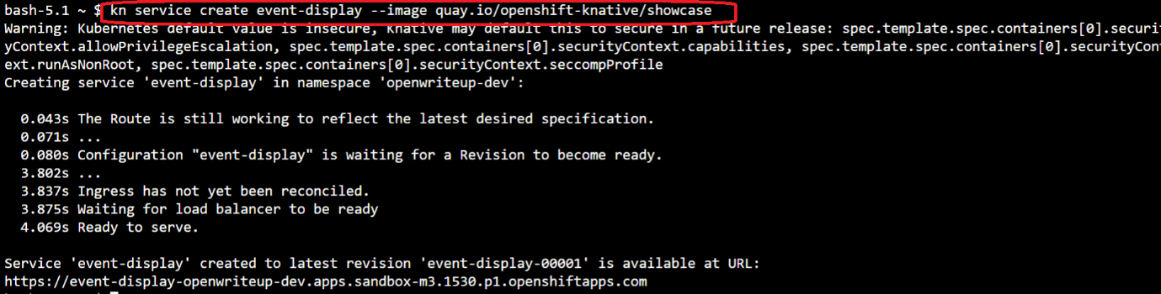

For each set of ping events that you want to request, create a ping source in the same namespace as the event consumer:

kn source ping create test-ping-source --schedule "*/2 * * * *" --data '{"message": "Hello world!"}' --sink ksvc:event-display



Check that the controller is mapped correctly by entering the following command and inspecting the output:

kn source ping describe test-ping-source

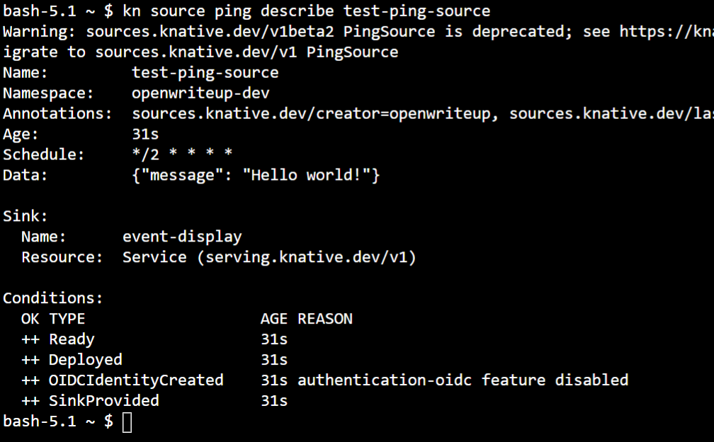

*Verification*

*Create a pod*

oc create deployment event-origin1 --image=quay.io/openshift-knative/showcase

Check the ping source events

1. Watch for new pods created:

**watch oc get pods**

1. Cancel watching the pods using Ctrl+C, then look at the logs of the created pod:

**oc logs $(oc get pod -o name | grep event-display) -c user-container**

